Build oven according to reference photos:

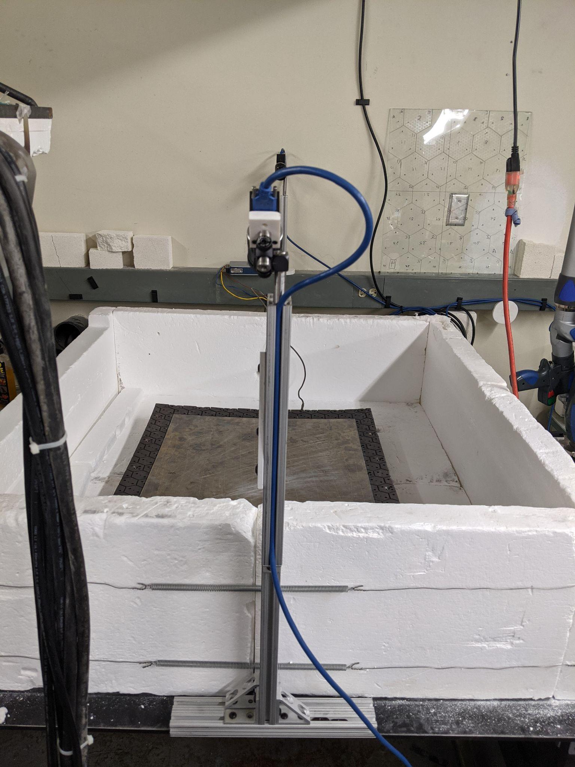

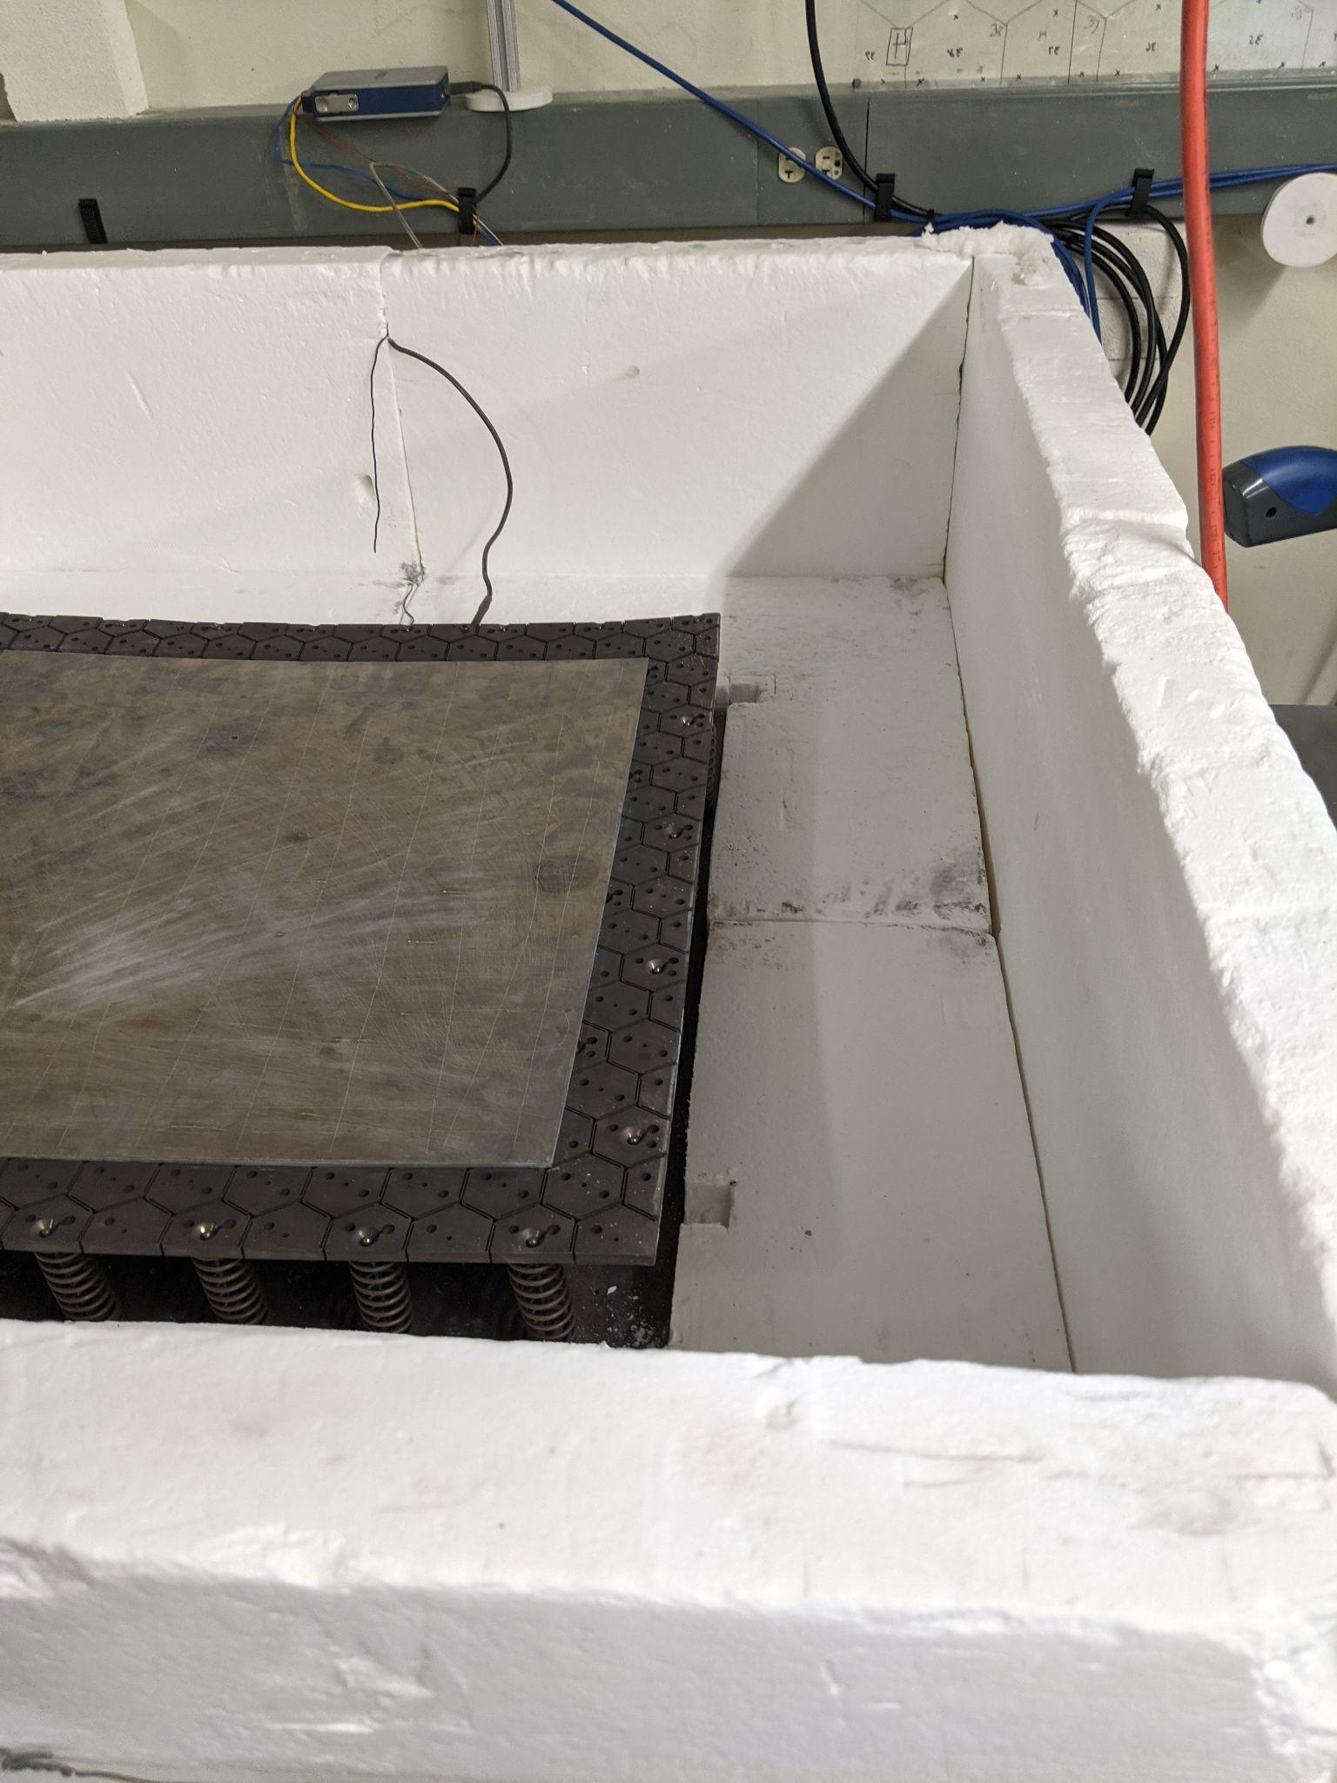

Indentations should be on side of mold closest to breaker box

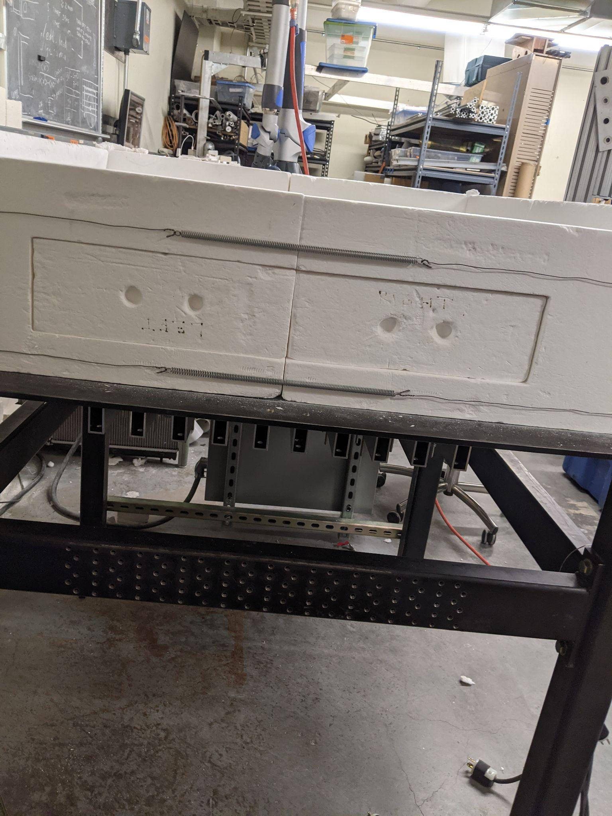

The oven window bricks should be closest to the jack

Putting the spring-tensioned corner braces around the oven is a two person job. Make sure the corners with the spring attachments that are lower than the others are on the side with the removable window blocks on it, in case the oven needs to be checked on while it is still hot.

Connect the heater plugs to their corresponding sockets, and connect the computer to the usb plug on the breaker box. Also make sure all the heater breakers are flipped over to the on position, they may have been turned off as a safety check.

Connect the thermometer controller’s blue usb hub to it’s correspond computer cable, and make sure the wires on the back to the different temperature probes looks like this:

Place the panel in the center of the mold, you should be able to see an oxidation mark that demarcates the locations. For a 495mm square panel on a 600mm square mold, you can center the panel on the mold by putting it 53mm from the edge of the mold. Place another steel flexure on top to weigh it down in a flexure panel sandwich

Jack down the lid and try to center it over the lid, it should be a little smaller than the oven itself.

Make sure COM 3 is chosen rather than COM 7 in the oven program. Set all all the intervals temp stage percentages to 60, except for the very last at 575, which can be set to 20. This will create a thermostat effect when the oven hits it’s peak temp. Start the oven by selecting Run Program Cycle from the Operating Mode drop down. Keep the oven running until the lower temp probe reaches a temperature of **517**, then changed Operating Mode to Stop.